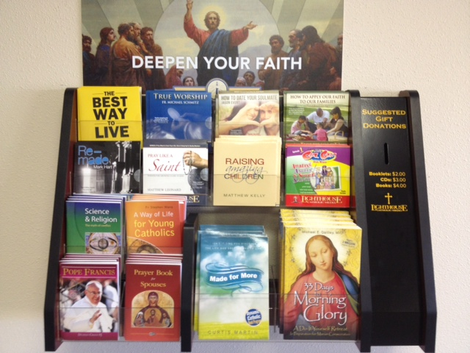

Prince of Peace Families
Our Lighthouse Catholic Media display, located downstairs, has many items to enrich your faith.

Highlight a CD, “Can You Trust God?”.
Since the fall of our first parents, humanity has been tempted to mistrust the love that God the Father has for us. Scripture scholar Dr. Tim Gray takes us on a journey that addresses the pervasive misconceptions that God is quick to anger, that the God of the Old and New Testaments are different, and that God doesn’t have a merciful heart for us. You will see that you can trust our heavenly Father, who is truly one with his Son.

Parishioner Comments:

This really helped me understand God and trust him even more.
- Patrick - Downers Grove, IL

This talk explained so well my lifelong struggle with trusting God, and made me see how much he really loves me.
- Julie - St. Petersburg, FL

Tim Gray opens our hearts to truly experience God as our merciful Father!
- Nancy - Union City, TN

